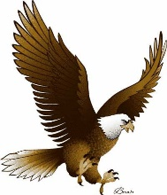**Moss Park Elementary**

**Fourth Grade Supply List**

**2018-2019**

**Please label these items with your child’s name:**

1 – Pair of headphones or ear buds to be kept at school

1 - 1.5 inch “D” ring binder w/ clear plastic cover and inside front & back pockets

5 - **plastic** folders with prongs and pockets: 1 blue, 1 green, 1 red, 1 yellow, 1 purple

2 - composition notebooks (100-pages)

1 pack of **plastic** subject dividers w/pockets (5 subjects-ELA, Writing, Math, Science, Social Studies)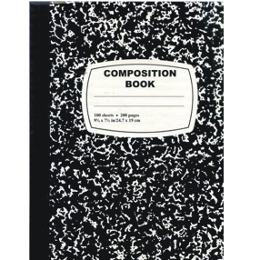

**Please do NOT label these items:**

1 pack of 25 page protectors

1 pack wide-ruled notebook paper

2 packs of 24 sharpened #2 pencils

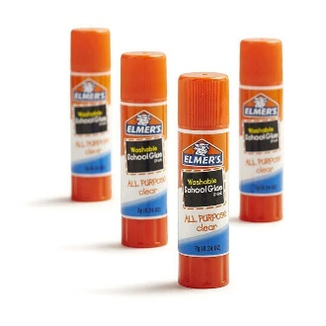1 box of colored pencils

1 box of crayons

1 3-Ring pencil pouch **(NO boxes, please)**

1 pair of scissors

4 glue sticks

8 wide dry erase markers (Expo Preferred)

1 ream of copy paper

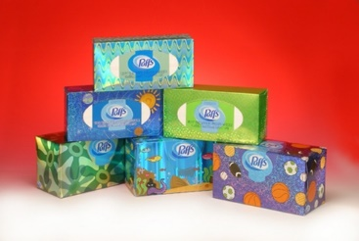2 box of tissues

1 container of Clorox/Lysol wipes

**Boys Girls**

Gallon size baggies Quart size baggies

1 box of bandages 1 bottle of liquid soap

Small Post-It notes Regular size Post-It notes

1 Pack Pencil cap erasers 3 Pack of Pink (jumbo) Pearl Erasers